**Project Development Phase**

**Sprint-2**

|  |  |
| --- | --- |
| **Team ID** | **PNT2022TMID50805** |
| **Project Name** | **Hazardous Area Monitoring for Industrial Plant powered by IOT** |

Node-Red Flow :

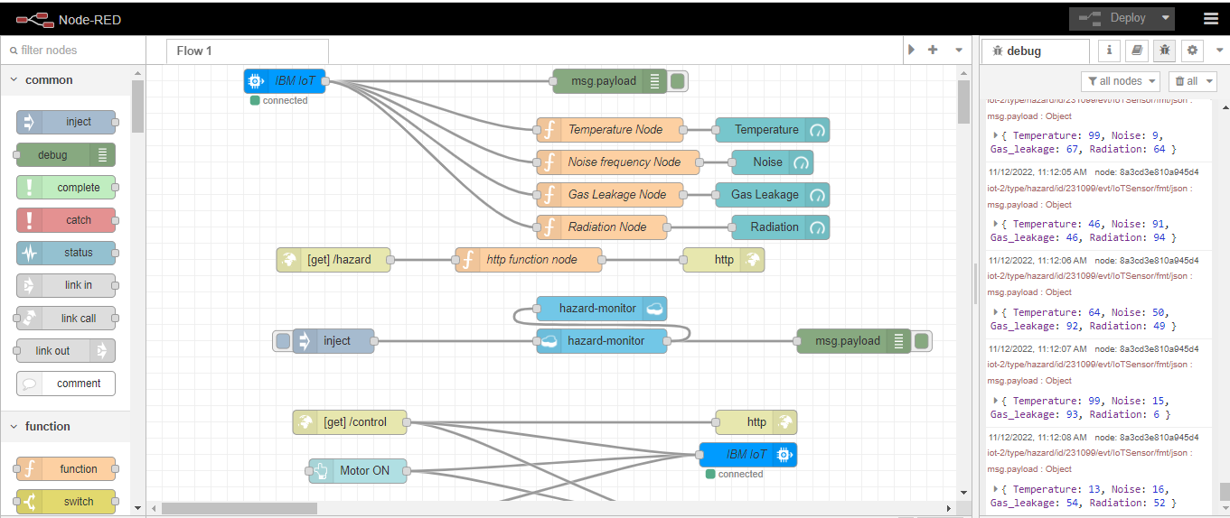

Designed UI:

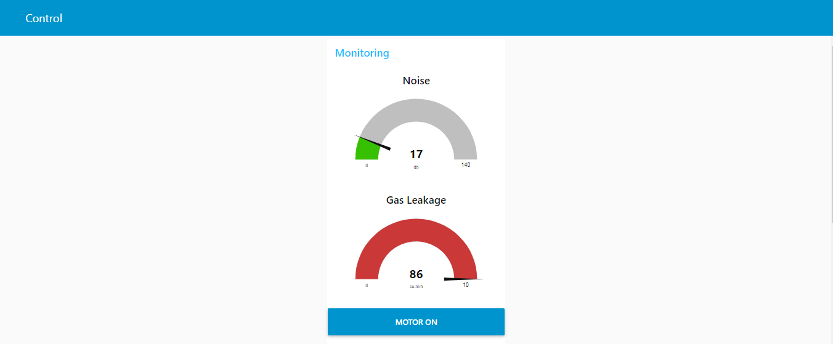

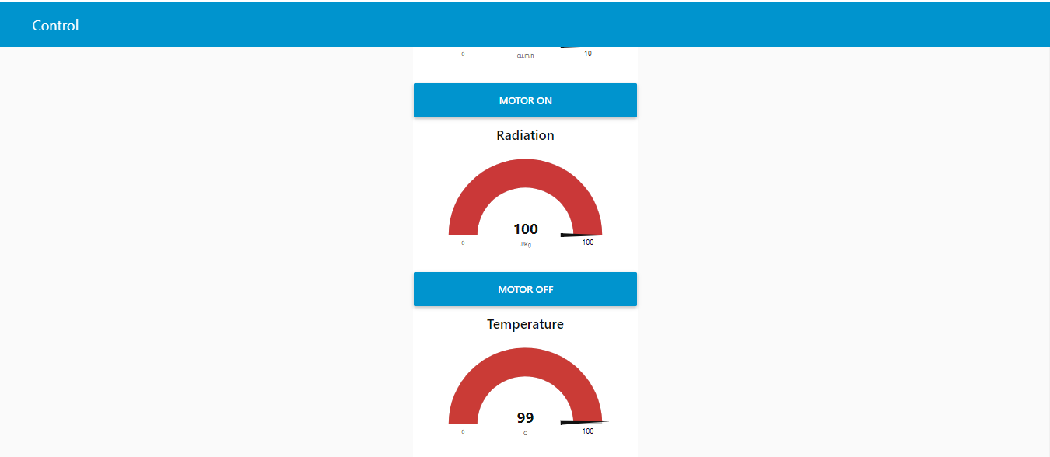

Received data from cloud.

